

Fortnightly Report

SIDBI – PMU Uttar Pradesh

**Period – 1st – 15th January 2023**

**Project Progress Report – Fortnightly**

|  |  |
| --- | --- |
| **SIDBI UP state PMU for MSME** | |
| **Location: Lucknow**  **Month & Year: January 2023**  **Fortnight Ending: January 15, 2023** | **Report Summary**  This report includes the activities carried out by SIDBI - PMU for the  facilitation of MSME ecosystem in the State of Uttar Pradesh. |

**Team Deployment Status**

|  |  |  |  |
| --- | --- | --- | --- |
| **Team** | | | |
| **SN** | **Designation** | **Name of Resource** | **Deployment Date** |
| 1 | PMU Manager | Jitendra Kumar | 6th Oct 2020 |
| 2 | Business Analyst | Md Zafar Iqbal Momin | 6th Oct 2020 – 8th Jan 2023 |
| 3 | Business Analyst | Pushpendra Tiwari | 9th Jan 2023 |

**Details of State Nodal Connect - Name – Ms. Ayushi Baranwal, Assistant Commissioner UP MSME, Mobile: 7800836855. Email:** [**odopcell@gmail.com**](mailto:odopcell@gmail.com)

**Activities performed by PMU during fortnight ending January 15, 2023**

|  |  |
| --- | --- |
| **Activity** | **Details of activities carried out** |
| 1. **Green Financing initiatives-**  * PMU has organised one virtual meeting with Mr. Anupam Shukla, IAS, Director, UP NEDA and Mr. R K Singh, CGM, Green Finance Vertical and Mr Manish Sinha, General Manager, SIDBI, ROLK. A detail discussion held for possible collaboration between SIDBI and UPNEDA. | |
| 1. **PMU Team extended support to SIDBI ROLK for organizing board meeting on 05-07-2023 at Varanasi**   PMU team is extending support in organizing board meeting –   * Prepared Arrangement blueprint * Prepared Itinerary * Prepared invitee list for RO and BO * Coordinated with Event Management Company * Coordination with the Taj Hotel * Coordinated with the Rudraksh convention center for organizing one event under SIDBI Project care   On January, 12-13, 2023, PMU team along with DGM SIDBI visited the Varanasi and met stakeholders to gather first-hand information of the venue. | |
| 1. **General agreement with RRBs**  * In accordance to RBI circular SIDBI ROLK through PMU is facilitating General Agreement with RRBs in UP. In this regard, PMU had approached 3 RRBs in the state- 1. Prathama Bank 2. Baroda bank of UP and 3. Aryavart Bank.   **Status Update on General Agreement with 3 RRB in UP are-**   1. **Prathama Bank**- GE to be done in February 2023 in Moradabad. 2. **Baroda bank**- The bank has yet to give confirmation for signing of the MoU 3. **Aryavat Bank-** A meeting between chairman Aryavat Bank and ROLK GM is proposed to finalize the modalities for signing of the MoU . | |
| 1. **Arrangement on SIDBI/Uttrayani Swavalamban Mela**  * SIDBI ROLK is sponsoring 30 Stalls in the mela. PMU reached out to prospective exhibitors. * PMU Team is assisting ROLK team in dissemination of various direct, indirect loan and green finance scheme to the visitors and to the exhibitors. | |
| 1. **Modalities of Pledge scheme (MSME Department)**  * PMU Team along with GM, SIDBI, ROLK met the ACS, and shared modalities that can be adopted by the MSME department for financing private developers at subsidized rate for establishment of Industrial Worker * PMU team also held one virtual meeting with SIDBI officials (Mr. Acharya, CGM and Ms Mamta Ravi of SCDF team) and explained potentials and drawbacks PLEDGE scheme | |
| 1. **SCDF update –**   PMU Team had facilitated SCDF in the State, details of which are-   * Rs 1000 Cr. in principle approval has been given to MSME dept. UP * On 29th Aug 2022- SIDBI had given In-principle approval of INR 2,000 crore to Energy Department * **PWD Department (Road etc.)** - On January 2,2023, SIDBI received a letter to confirm the consent/readiness of SIDBI to finance mentioned projects. The PMU team drafted a reply letter for the same. * **Energy Department** – PMU team Followed up with energy department officials to finalise the list for in principal approval of INR 2000 cr. On January 04, 2023 the department shared a list of prospective projects. After virtual discussion with the SIDBI team the Energy department finalised the list. The PMU team followed up with the department to send the proposal vetted by the finance department. * **MSME Department** –On December 6, 2022, PMU team along with the GM. SIDBI meet ACS, MSME and discussed PLEDGE schemes for Private Industrial Parks in which it is proposed to create a corpus of INR 500cr with the help of SCDF. PMU Team along with GM, SIDBI, ROLK met the ACS, and shared modalities that can be adopted by the MSME department for financing private developers at subsidized rate for establishment of Industrial Worker. * **Meeting with Finance Department** - January 13, 2023, PMU organised one meeting between GM,SIDBI and ACS, Finance Department. GM SIDBI requested to forward the request of PWD demand letter to SIDBI for in-principle approval. | |

|  |
| --- |
| **Actionable and Support required** |
| * MSME department to send formal communication for financing PLEDGE scheme * State Government to on-board TReDS platform- RXIL |
| **Activities Way forward** |
| * Vendor development programme with Tata Motors * General Agreement with SIDBI and RRBs in UP |
| **Inputs of State Nodal Connect / Officer** |
| 1. SIDBI to collaborate with State Government for GIS 2023 |

1. **Snapshot of the activity-**

Meeting with Director Mr. Anupam Shukla, IAS, Director UP NEDA for Green finance initiatives

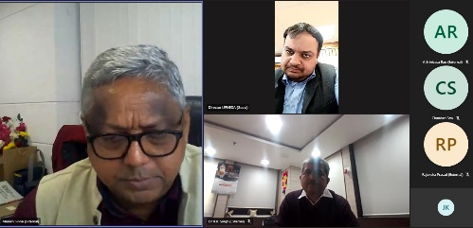

1. **Snapshots of the Swavlamman/ Utrayani Mela-**

## 

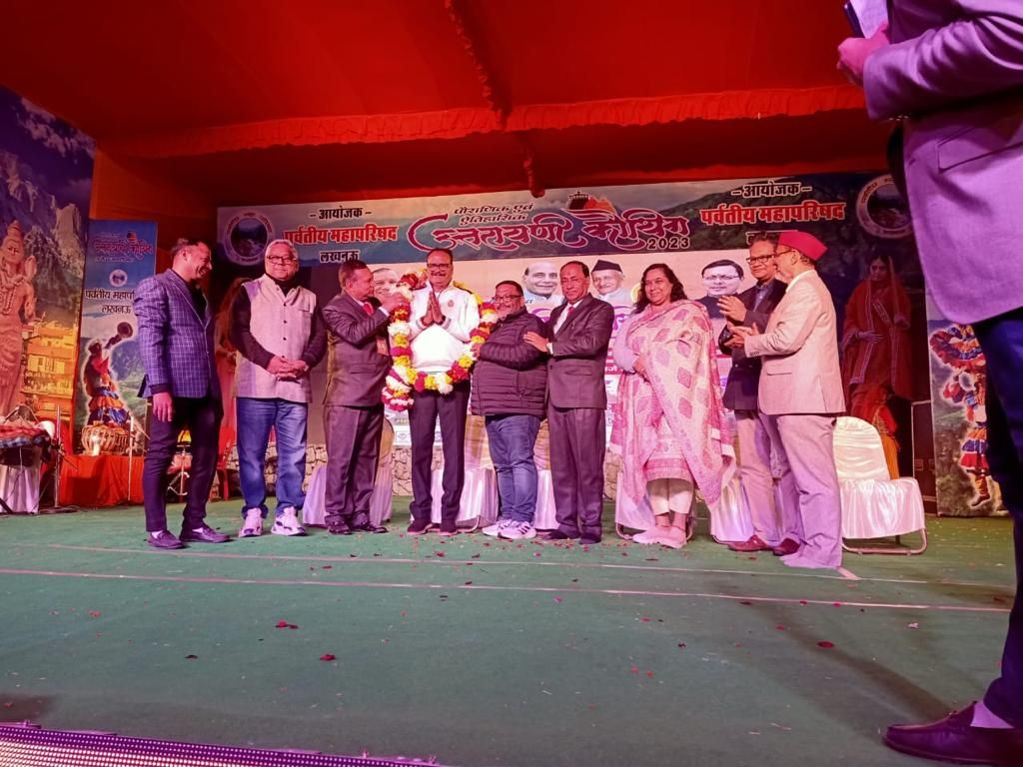

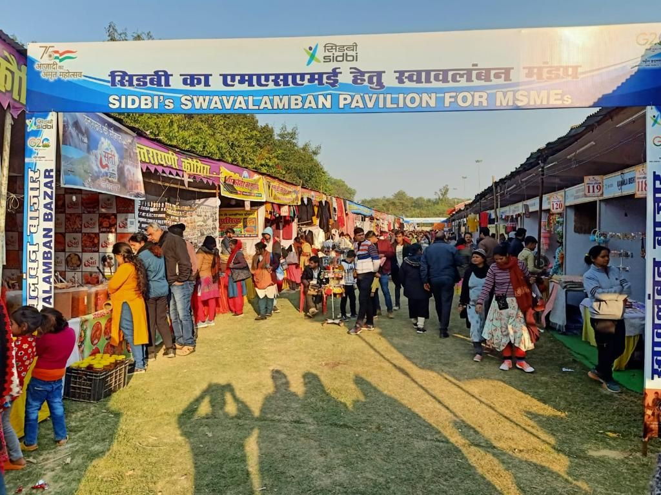 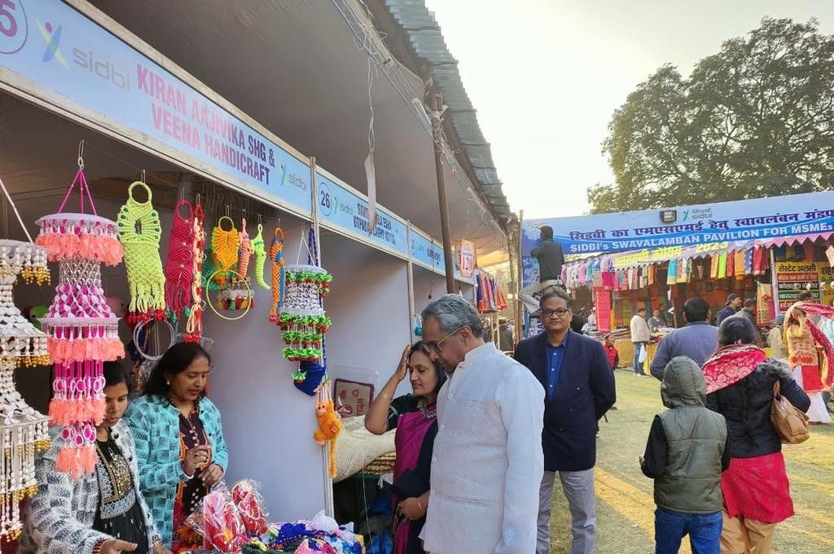

**Contact us**

*****************

To know more, please visit [**www.grantthornton.in**](http://www.grantthornton.in/) or contact any of our offices as mentioned below:

|  |  |  |  |  |
| --- | --- | --- | --- | --- |
| **NEW DELHI**  National Office, Outer Circle, L 41, Connaught Circus, New Delhi - 110001 T +91 11 4278 7070 | **NEW DELHI**  6th Floor, Worldmark 2, Aerocity,  New Delhi - 110037 T +91 11 4952 7400 | **AHMEDABAD**  7th Floor, Heritage Chambers,  Nr Azad Society, Nehru Nagar, Ahmedabad - 380015 | **BENGALURU**  5th Floor, 65/2, Block A, Bagmane Tridib, Bagmane Tech Park, CV Raman Nagar, Bengaluru - 560093  T+91 80 4243 0700 | **CHANDIGARH**  B-406A, 4th Floor, L&T Elante Office Building, Industrial Area Phase I, Chandigarh - 160002  T +91 172 4338 000 |
| **CHENNAI**  7th Floor, Prestige Polygon,  471, Anna Salai, Teynampet, Chennai - 600018  T +91 44 4294 0000 | **DEHRADUN**  Suite No 2211, 2nd Floor, Building 2000, Michigan Avenue, Doon Express Business Park,  Subhash Nagar, Dehradun - 248002  T +91 135 2646 500 | **GURGAON**  21st Floor, DLF Square, Jacaranda Marg, DLF Phase II,  Gurgaon - 122002  T +91 124 462 8000 | **HYDERABAD**  7th Floor, Block III, White House,  Kundan Bagh, Begumpet, Hyderabad - 500016  T +91 40 6630 8200 | **KOCH**I  6th Floor, Modayil Centre Point, Warriam Road Junction, MG Road Kochi - 682016  T +91 484 406 4541 |
| **KOLKATA**  10C Hungerford Street, 5th Floor,  Kolkata - 700017  T +91 33 4050 8000 | **MUMBAI**  11th Floor, Tower II,  One International Center, SB Marg Prabhadevi (W), Mumbai - 400013  T +91 22 6626 2600 | **MUMBAI**  Kaledonia, 1st Floor, C Wing, (Opposite J&J Office),  Sahar Road, Andheri East,  Mumbai - 400 069 | **NOIDA**  Plot No 19A, 2nd Floor, Sector - 16A,  Noida - 201301  T +91 120 485 5900 | **PUNE**  3rd Floor, Unit No 309- 312, West Wing, Nyati Unitree, Nagar Road, Yerwada  Pune - 411006  T +91 20 6744 8800 |

For more information or for any queries, write to us at [**contact@in.gt.com**](mailto:contact@in.gt.com)

|  |  |
| --- | --- |
| Twitter-outline | **Follow us @GrantThorntonIN** |

**Small Industries Development Bank of India (SIDBI),** established under an Act of Parliament in 1990, acts as the Principal Financial Institution for Promotion, Financing and Development of the Micro, Small and Medium Enterprise (MSME) sector as well as for co-ordination of functions of institutions engaged in similar activities. In the context of the changing MSME lending landscape, the role of SIDBI has been realigned through adoption of SIDBI Vision 2.0 which envisages an integrated credit and development support role of the Bank by being a thought leader, adopting a credit-plus approach, creating a multiplier effect and serving as an aggregator in MSME space.





***Disclaime****r: This document is prepared under SIDBI intervention in which Grant Thornton Bharat LLP is the implementing agency. The document users/third parties shall verify the facts and figures at their end and shall be solely liable for any action taken by it based on this document. SIDBI, its directors, employees or any office shall not be liable for loss of whatsoever nature arising by using the content of this document.*